**MODEL TRANSFORMATIONS MATRICES FROM A LINEAR ALGEBRA STAND POINT**

**Vector spaces** are represented with a **set of basis vectors** and **matrices** are **vector sets**, so, we can use **matrices** for represent **vector spaces**. This way we can represent the following vector space using the matrix $S$

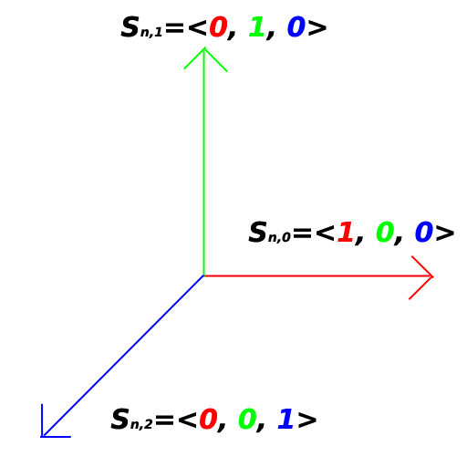

Where $n=0, 1, 2$

And $S= \left[\begin{matrix}S_{n, 0} & S_{n, 1} & S_{n, 2}\end{matrix}\right]=\left[\begin{matrix}1 & 0 & 0 \\ 0 & 1 & 0 \\ 0 & 0 & 1\end{matrix}\right]$

And in homogenous coordinates we have that $S= \left[\begin{matrix}\begin{matrix}\begin{matrix}\begin{matrix}1 \\ 0\end{matrix} \\ \begin{matrix}0 \\ 0\end{matrix}\end{matrix} & \begin{matrix}\begin{matrix}0 \\ 1\end{matrix} \\ \begin{matrix}0 \\ 0\end{matrix}\end{matrix}\end{matrix} & \begin{matrix}\begin{matrix}\begin{matrix}0 \\ 0\end{matrix} \\ \begin{matrix}1 \\ 0\end{matrix}\end{matrix} & \begin{matrix}\begin{matrix}0 \\ 0\end{matrix} \\ \begin{matrix}0 \\ 1\end{matrix}\end{matrix}\end{matrix}\end{matrix}\right]$

Thus we can say that matrix $S$ represent the standard basis in homogenous coordinates, and if we want represent column vector $x={\left[\begin{matrix}1 & 0 & \begin{matrix}0 & 0\end{matrix}\end{matrix}\right]}^{T}$ into the standard vector space we could simply say that $S$ is a transformation matrix

$Sx=c where x=c in this particular case (no transformation occurs in vector x)$

If we want transform our vector $x,$ let’s say rotate it $θ$ radians anti-clockwise along z axis we must define a new $A$ matrix that defines a new vector basis that is relative to the standard basis.

**POSSIBLE INTERPRETATIONS**

In the vector transformation $Ax=c$

We can say that **c** is a vector identical to **x** but represented in a different vector basis (which is represented in the columns of matrix **A )**

We can say that **c** represents a vector rotated by $θ$ radians anti-clockwise along z axis